**CHAPTER 3**

**SYSTEM DESIGN AND IMPLEMENTATION**

This system is Hash Based Duplicate Words Checking System using open hashing (separate chaining) mechanism. It is suitable for students and people who are interested in English. This English vocabulary game can help students collect new English words from playing game.

**3.1 System Design**

Figure 3.1 is system design for Hash Based Duplicate Words Checking System. This system accepts English vocabularies as input and check input word for duplication, mismatch and whether the word is existed in database or not. When the game ends, it generates player scores and determines whether the player passes or fails level.

Start

End

Check duplication, mismatch and exist in database

Words

Player’s scores

**Figure 3.1 Proposed System Design**

**3.2 System Flow**

Figure 3.2 is the system flow for this system. The system asks user name and password from old player. For new player, the system asks player name, password and confirmed password to choose level for player.

Start

Name and password

Generate and input word

Database

Check word

Exist in DB?

Reduce 1 point from scores

Search in hash table

Exist word?

Check last char of previous word and first char of next word

Match character?

Add 1 point into scores and word into hash table

More games?

Player’s scores

End

Reduce 2 points from scores

No Yes

Yes No

No Yes

Yes No

**Figure 3.2 System Flow**

**3.3 System Implementation**

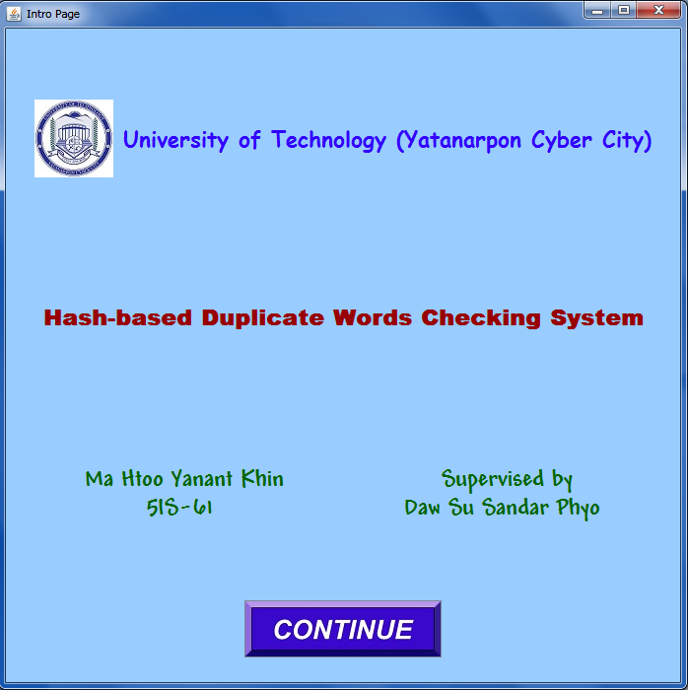

**Figure 3.3 Intro Page**

When the program starts, the user can see intro page initially. This page introduces the name of the system, student’s name (who writes coding for this system) and supervisor (who guides to complete this system). It also contains continue button to go next page.

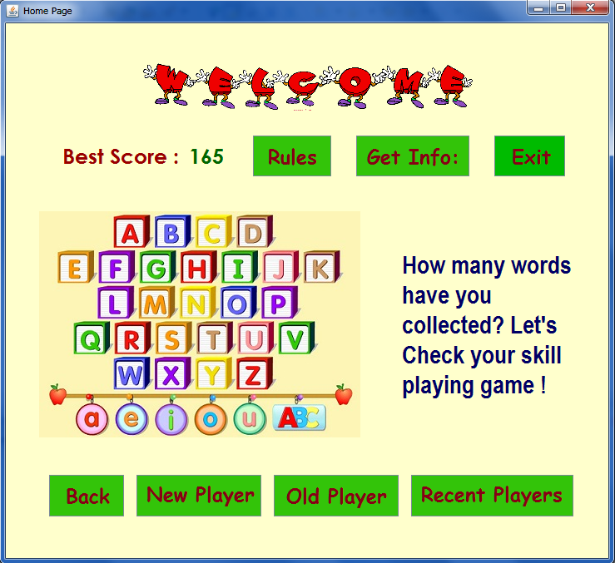

**Figure 3.4 Home Page**

In home page, Get Info, Rules, Exit, Back, New Player, Old Player and Recent Players buttons are included. When the player clicks New Player or Old Player button, it shows respective dialog for each button.

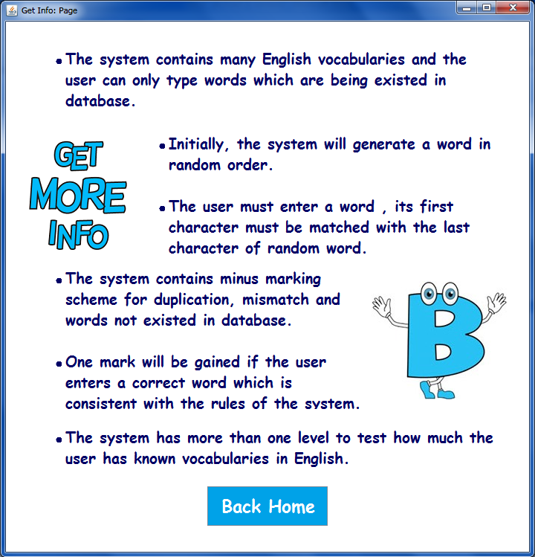

**Figure 3.5 Get Info Page**

This page will be seen when the player clicks Get Info button from home page. If the player wants to go back, he or she can return to home page by clicking Back Home button.

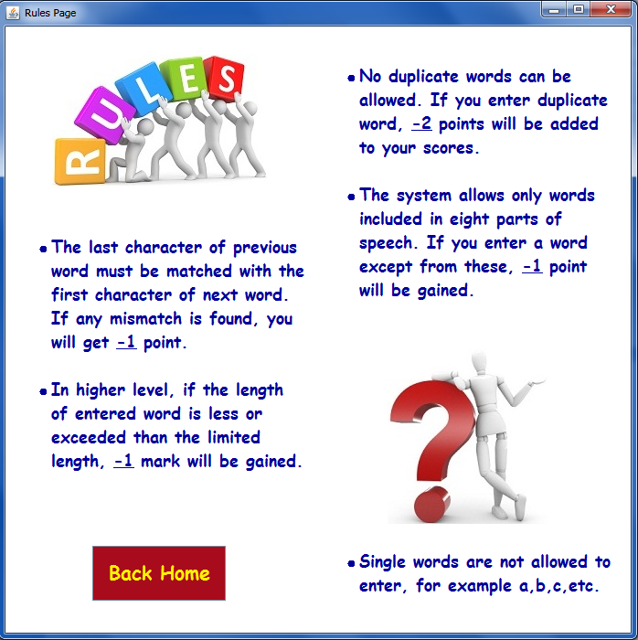

**Figure 3.6 Rules Page**

This page is shown when Rules button from home page is clicked. In this page, it shows the rules of the system which the player must obey to play game. It also describes minus marking for mismatch, duplication and words which are not existed in database.

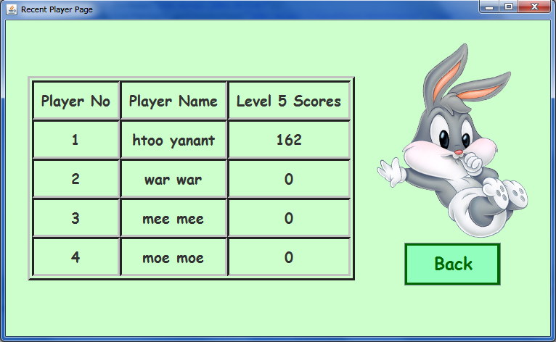

**Figure 3.7 Recent Player Page**

The player can see this page by clicking Recent Player button from home page. It shows the list of all players (who played this game) in table. Back button goes home page back.

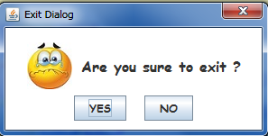

**Figure 3.8 Exit Dialog**

Exit dialog box is shown if the player clicks Exit button from home page. The system terminates entirely by clicking YES button in dialog.

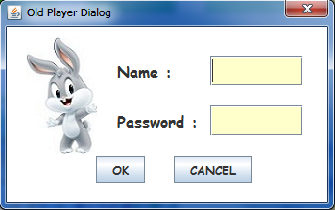

**Figure 3.9 Old Player Dialog**

The player can see this dialog box by clicking Old Player button in home page. It will ask player name and password. After entering two inputs, OK button is pressed.

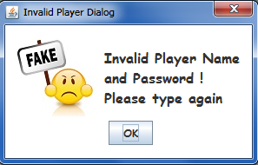

**Figure 3.10 Invalid Player Dialog**

If the player enters incorrect name and password, Invalid Player Dialog box is shown to player.

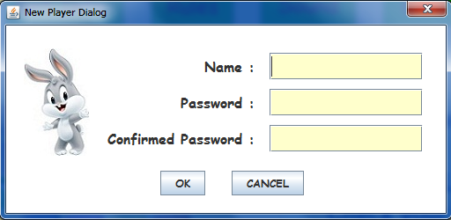

**Figure 3.11 New Player Dialog**

The player can see this dialog box by clicking New Player button in home page. It will ask player name, password and confirmed password. After entering two inputs, OK button is pressed.

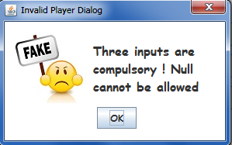

**Figure 3.12 Invalid Player Dialog**

Figure 3.12 is shown when the player enters null for input.

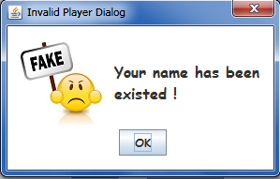

**Figure 3.13 Invalid Player Dialog of Existing Name**

The dialog box (figure 3.13) will be displayed if the entered player name is existed in database and the player must enter different name.

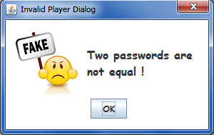

**Figure 3.14 Invalid Player Dialog of Mismatched Passwords**

The dialog box (figure 3.14) will be shown if the two passwords are not equal. Inputs for password and confirm password must be same.

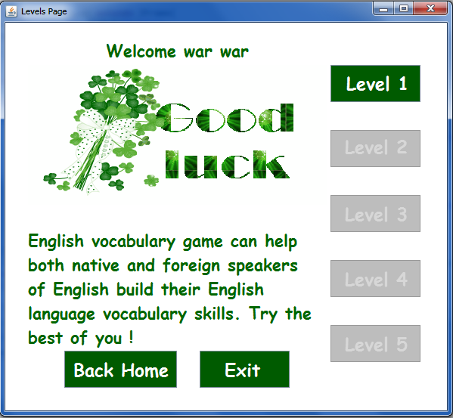

**Figure 3.15 Levels Page of New Player**

Figure 3.15 is levels page for new player who has not passed any level. For all beginners, only Level 1 button is enabled. Only if the player can pass level one, Level 2 button will be enabled. Back Home button is used to go back home and Exit button is used to end game.

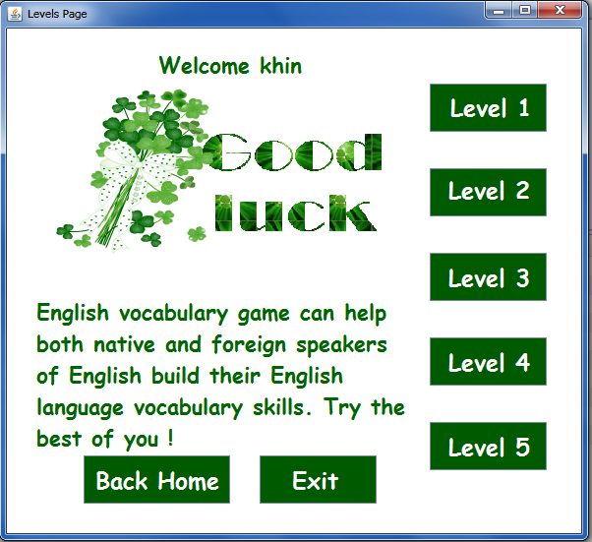

**Figure 3.16 Levels Page for Old Player**

Figure 3.16 is Levels Page for old player who has passed all five levels. So he or she is able to click all buttons. Although the user is old player, he or she can click buttons only when he or she has passed levels. For example, if the player has passed level one, Level 2 button is enabled and if level two is passed, Level 3 button is enabled.

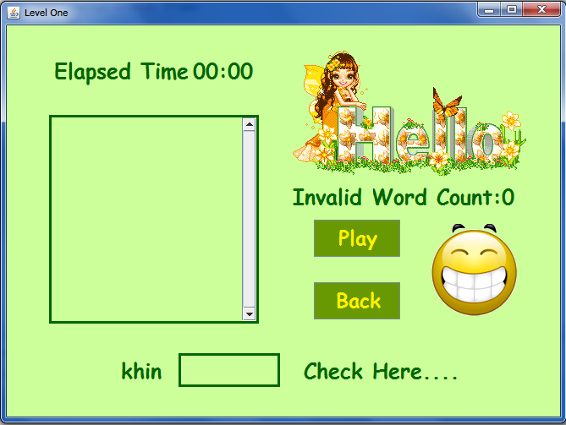

**Figure 3.17 Initial State for Level One**

Figure 3.17 is the initial state for level one. When the player clicks Play button, the system generates a random word in text area and Elapsed Time will be increased. Happy face icon will be changed when the player enters words which are not consistent with the rules of the system. The phrase “Check Here…” is changed into “Duplication, Mismatch or Not Existed” with red color for invalid words. The phrase will be changed as soon as the player presses enter key. Back button is used to go home page.

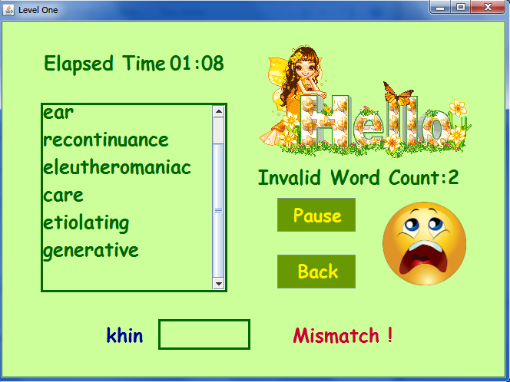

**Figure 3.18 State for Invalid Word in Level One**

Figure 3.18 shows mismatch state when the player enters words which first character is not matched with last character of previous word. Invalid words are not added into text area but invalid word count is increased. States for duplication and words not existed in database are the same way.

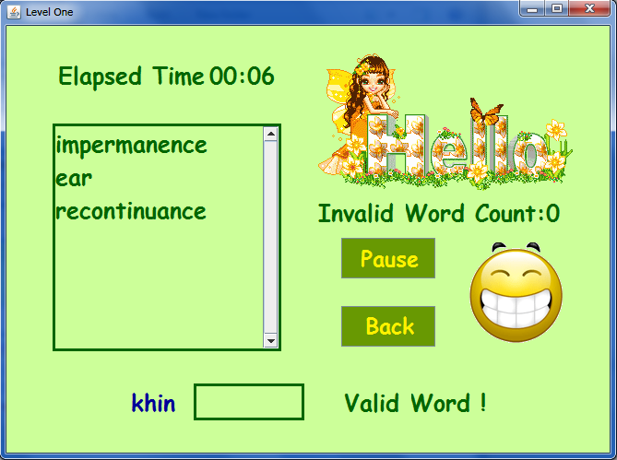

**Figure 3.19 State for Valid Word in Level One**

In figure 3.19, if the player enters valid word, the phrase is changed into “Valid Word!” and face icon is replaced with happy icon. Level two, level three, level four and level five will work the same as level one.

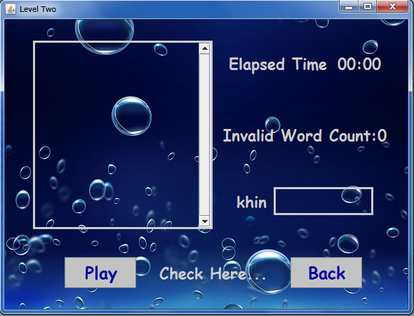

**Figure 3.20 Level Two Page**

Figure 3.20 contains two buttons: Play and Back buttons. Play button is used to start game and back button can go back to level page. Before going to level page, it shows completed dialog or fail dialog depends on the player’s scores.

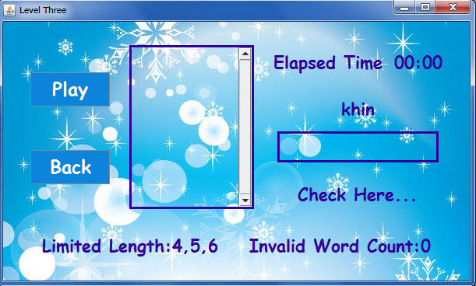

**Figure 3.21 Level Three Page**

Level three page includes Play and Back buttons. Play button is used to begin game and back button can go back to level page. Before going to level page, it shows completed dialog or fail dialog depends on the player’s scores. The player can type only words which are composed of four, five or six characters.

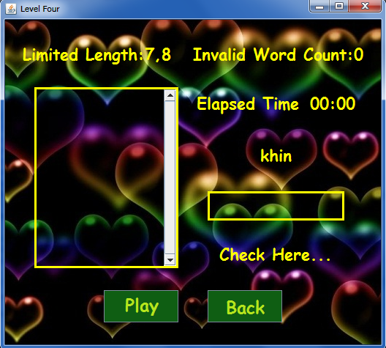

**Figure 3.22 Level Four Page**

There are two buttons in level four page. Play button is used to begin game and back button can go back to level page. Before going to level page, it shows completed dialog or fail dialog depends on the player’s scores. The player can type only words which are composed of seven or eight characters.

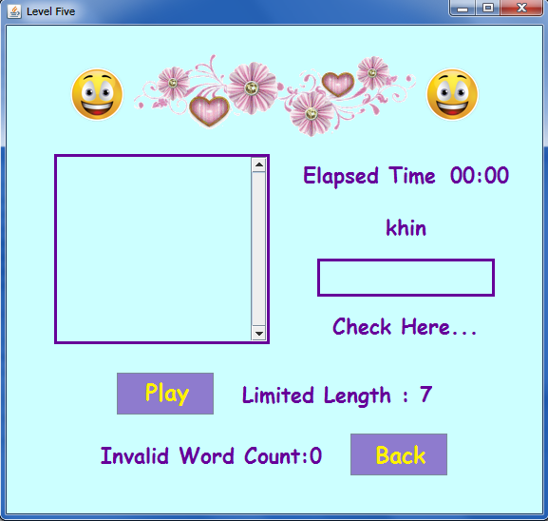

**Figure 3.23 Level Five Page**

In level five (figure 3.23), limited length is a random number between 3 and 14. Random number is changing whenever the player presses enter key.

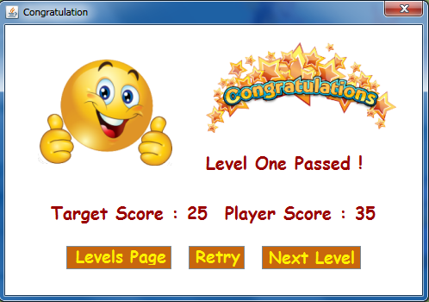

**Figure 3.24 Level One Completed Dialog**

Figure 3.24 shows completed dialog box after the player has passed level one. This dialog box contains three buttons (Levels Page button, Retry button and Next Level button). If the player wants to go levels page, he or she can go with just one click on Levels Page button. The player can retry this level by clicking Retry button. Next level can be reached by pressing Next Level button in dialog. Level two, level three and level four work the same work.

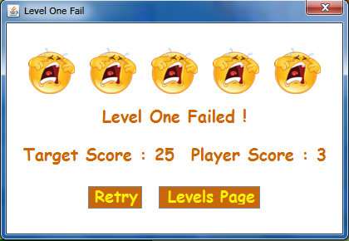

**Figure 3.25 Level One Fail Dialog**

If the player cannot reach target score in level one, dialog (figure 3.25) is displayed. It also contains Retry and Levels Page button which work the same as in congratulation dialog. If the player fails level two, level three, level four or level five, it will work the same as level one.

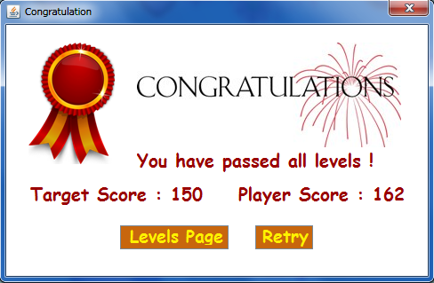

**Figure 3.26 Congratulation Dialog for Level Five**

Figure 3.26 will be seen after level five (final level) has been passed. If the player sees this dialog, it is sure that five buttons in Levels Page will be able to click.

* 1. **Output of the System**

The system generates the player’s scores depending on typing skill and how much words the user has learned. The system also shows the target scores for each level and determines whether the level is passed or not. Depending on player’s scores, the system determines which level button should be enabled to click.